**IN THE HIGH COURT OF JUSTICE Claim No. PT-2022-000303**

**BUSINESS AND PROPERTY COURTS OF ENGLAND AND WALES**

**CHANCERY DIVISION**

**PROPERTY TRUSTS AND PROBATE LIST**

**[…]**

**[…]**

**B E T W E E N**

**(1) UNITED KINGDOM OIL PIPELINES LIMITED**

**(2) WEST LONDON PIPELINE AND STORAGE LIMITED**

**Claimants / Applicants**

**and**

1. **PERSONS UNKNOWN ENTERING OR REMAINING WITHOUT CONSENT, AND IN CONNECTION WITH OR AFFILIATED TO THE EXTINCTION REBELLION CAMPAIGN OR THE JUST STOP OIL CAMPAIGN, ON LAND AND BUILDINGS AT AND COMPRISING PART OF (A) THE BUNCEFIELD OIL TERMINAL, HEMEL HEMPSTEAD, HERTFORDSHIRE (SHOWN FOR IDENTIFICATION SHADED RED ON THE ATTACHED SITE 1 PLAN) (B) THE KINGSBURY OIL TERMINAL, KINGSBURY, WARWICKSHIRE (SHOWN FOR IDENTIFICATION SHADED RED ON THE ATTACHED SITE 2 PLAN)**

**First Defendants/Respondents**

**(2) PERSONS UNKNOWN WITHOUT CONSENT, AND IN CONNECTION WITH OR AFFILIATED TO THE EXTINCTION REBELLION CAMPAIGN OR THE JUST STOP OIL CAMPAIGN, OBSTRUCTING OR INTERFERING WITH THE FIRST CLAIMANT'S ACCESS OVER PRIVATE ACCESS ROADS ADJACENT TO (A) THE BUNCEFIELD OIL TERMINAL, HEMEL HEMPSTEAD, HERTFORDSHIRE (SHOWN FOR IDENTIFICATION SHADED BLUE ON THE ATTACHED SITE 1 PLAN) (B) THE KINGSBURY OIL TERMINAL, KINGSBURY, WARWICKSHIRE (SHOWN FOR IDENTIFICATION SHADED BLUE ON THE ATTACHED SITE 2 PLAN)**

**Second Defendants/Respondents**

**___________________________________________________**

**DRAFT ORDER AGAINST THE FIRST AND SECOND DEFENDANTS**

**(COLLECTIVELY “THE DEFENDANTS”)**

**___________________________________________________**

**PENAL NOTICE**

**IF YOU, THE DEFENDANTS, DISOBEY THIS ORDER YOU MAY BE HELD TO BE IN CONTEMPT OF COURT AND MAY BE IMPRISONED, FINED OR HAVE YOUR ASSETS SEIZED.**

**ANY OTHER PERSON WHO KNOWS OF THIS ORDER AND DOES ANYTHING WHICH HELPS OR PERMITS THE DEFENDANTS OR ANY OF THEM TO BREACH THE TERMS OF THIS ORDER MAY ALSO BE HELD TO BE IN CONTEMPT OF COURT AND MAY BE IMPRISONED, FINED OR HAVE THEIR ASSETS SEIZED.**

**IMPORTANT NOTICE TO THE DEFENDANTS**

This Order prohibits you from doing certain acts. You should read this Order very carefully. You are advised to consult a solicitor as soon as possible.

If you disobey this Order you may be found guilty of contempt of court and you may be sent to prison or your assets seized.

You have the right to apply to the court to vary or discharge this order (which is explained below).

**RECITALS**

**UPON** the hearing of the Claimants’ Application dated 8 April 2022

**UPON** hearing Leading Counsel and Junior Counsel for the Claimants

**AND UPON READING** the evidence recorded on the Court file as having been read

**AND UPON** the Claimants giving and the Court accepting the undertaking listed in Schedule 3

**AND UPON** the Claimants acknowledging that they do not intend to prohibit any lawful protest outside any of the sites referred to in this Order and that this Order is not intended to prohibit such lawful protest

**IT IS ORDERED THAT:**

**THE INJUNCTIONS**

1. Until trial or further order:
   * + 1. **BUNCEFIELD (SITE 1)**
2. The First Defendants and each of them are forbidden from (a) entering or remaining upon the land or buildings described in and defined as "**Buncefield (Site 1)**" in Schedule 2 to this Order and which are shown for illustration purposes shaded red on the plan annexed to Schedule 4 of the Order (“**the Site 1 Plan**”), or (b) from causing damage to Buncefield (Site 1) or (c) removing equipment from Buncefield (Site 1), without the consent of the Claimants.
3. The Second Defendants and each of them are forbidden from obstructing or otherwise interfering with the First Claimant’s access over the private access road on the land adjoining Buncefield Site 1 (the "**Site 1 Access Route**"), which is shown for illustration purposes shaded blue on the Site 1 Plan, for access and egress between Buncefield (Site 1) and the public highway.

**(b)** **KINGSBURY (SITE 2)**

1. The First Defendants and each of them are forbidden from (a) entering or remaining upon the land or buildings described in and defined as "**Kingsbury (Site 2)**" in Schedule 2 to this Order and which are shown for illustration purposes shaded red on the plan annexed to Schedule 5 of the Order (the “**Site 2 Plan**”) or (b) from causing damage to Kingsbury (Site 2) or (c) removing equipment from Kingsbury (Site 2), without the consent of the First Claimant.
2. The Second Defendants and each of them are forbidden from obstructing or otherwise interfering with the First Claimant’s access over the private access road on the land adjoining Site 2 (the "**Site 2 Access Route**"), which is shown for illustration purposes shaded blue on the Site 2 Plan, for access and egress between Kingsbury (Site 2) and the public highway.

**VARIATION OF THIS ORDER**

1. Anyone served or notified of this Order may apply to the Court at any time to vary or discharge this Order or so much of it as affects that person but they must first give the Claimants' solicitors 48 hours’ notice of such application. If any evidence is to be relied upon in support of the application the substance of it must be communicated in writing to the Claimants' solicitors at least 24 hours in advance of any hearing.
2. Any person applying to vary or discharge this Order must provide their full name and address, an address for service and must also apply to be joined as a named defendant to the proceedings at the same time.
3. The Claimants have liberty to apply to extend or vary this Order or to seek further directions.

**INTERPRETATION OF THIS ORDER**

1. A Defendant who is ordered not to do something must not do it him/herself/themselves or in any other way. He/she/they must not do it through another acting on his/her/their behalf or on his/her/their instructions or with his/her/their encouragement.

SERVICE OF THIS ORDER

1. Pursuant to CPR 6.15, 6.27 and 81.4(2)(c) and (d), service of this Order, shall be effected as follows:
   * + 1. Fixing copies thereof in clear transparent sealed containers at a minimum number of 2 prominent locations on the perimeter of each of the Sites together with a notice which states that copies of the Order may be obtained from the Claimants’ solicitors, Fieldfisher LLP, Riverbank House, 2 Swan Lane, London, EC4R 3TT (tel: 020 7861 4000) email: [UKOPinjunction@fieldfisher.com](mailto:UKOPinjunction@fieldfisher.com) via, and may be viewed at, the web link referred to in paragraph 10(b) of this Order;
       2. Posting the Order at the following web link: <https://ukop.azurewebsites.net>;
       3. Fixing warning notices (in substantially the same form as those set out in Schedule 6 and 7 to the Order dated 8 April 2022, but as amended to reflect the terms of this Order) as follows in not less than A2 size:
          1. In respect of **Buncefield (Site 1)** by affixing the form of site injunction notice (the "**Site 1 Notice**") in clearly visible locations (including at entranceways, access points, gates and attached to the perimeter fencing) around and comprising part of Site 1; and
          2. In respect of **Kingsbury (Site 2)** by affixing the form of site injunction notice (the "**Site 2 Notice**") in clearly visible locations (including at entranceways, access points, gates and attached to the perimeter fencing) around and comprising part of Kingsbury (Site 2);
       4. Sending an email to each of the following email addresses with the information that copies of the Order may be viewed at the web link referred to in paragraph 10(b) above:
          1. [xr-legal@riseup.net](mailto:xr-legal@riseup.net);
          2. [juststopoil@protonmail.co.uk](mailto:juststopoil@protonmail.co.uk)
2. Pursuant to CPR 6.15(3), 6.27 and 81.4(2)(c) and (d), the Order will be deemed to be served on the latest date on which all of the methods of service referred to above have been completed, such date to be verified by the completion of a certificate of service.
3. Pursuant to CPR 6.15, 6.27 and 81.4(2)(c) and (d), the steps identified above shall stand as good service of the Order.

**ALTERNATIVE SERVICE PROVISIONS FOR FUTURE APPLICATIONS BY THE CLAIMANTS IN THIS CLAIM**

1. Pursuant to CPR 6.15, 6.27 and 81.4(2)(c) and (d), service of any future applications in this Claim by the Claimants and their evidence in support, shall be effected as follows:
   * + 1. Fixing copies thereof in clear transparent sealed containers at a minimum number of 2 prominent locations on the perimeter of each of the Sites together with a notice which states that copies of the documents may be obtained from the Claimants’ solicitors, Fieldfisher LLP, Riverbank House, 2 Swan Lane, London, EC4R 3TT (tel: 020 7861 4000) email: [UKOPinjunction@fieldfisher.com](mailto:UKOPinjunction@fieldfisher.com) via, and may be viewed at, the web link referred to in paragraph 13(b) of this Order;
       2. Posting copies of these documents at the following web link: <https://ukop.azurewebsites.net>;
       3. Sending an email to each of the following email addresses with the information that copies of the documents may be viewed at the web link referred to in paragraph 13(b) above:
          1. [xr-legal@riseup.net](mailto:xr-legal@riseup.net);
          2. [juststopoil@protonmail.co.uk](mailto:juststopoil@protonmail.co.uk)
2. Pursuant to CPR 6.15(3), 6.27 and 81.4(2)(c) and (d), any documents served pursuant to the provision in paragraph 13 above will be deemed to be served on the latest date on which all of the methods of service referred to in paragraph 13 above have been completed in respect thereof, such date to be verified by the completion of a certificate of service.
3. Pursuant to CPR 6.15, 6.27 and 81.4(2)(c) and (d), the steps identified in paragraph 13 above shall stand as good service.

**COSTS**

1. Costs reserved.

**COMMUNICATIONS WITH THE COURT**

1. All communications about this Order should be sent to:

Court Manager

High Court of Justice

Chancery Division

Rolls Building

7 Rolls Building

Fetter Lane

London

EC4A 1NL

The telephone number is 020 7947 7501. The offices are open weekdays 10.00 a.m. to 4.30 p.m.

Out of hours telephone number is 020 7947 6260

1. Name and address of the Claimants' legal representatives

Fieldfisher LLP

Riverbank House

2 Swan Lane

London

EC4R 3TT

Telephone: 020 7861 4000

Fax: 020 7488 0084

Out of hours telephone number: 07711 088057

Reference: OTD/UK01.000162.00301

This Order shall be served by the Claimants on the Defendants. The Court has provided a sealed copy of this Order to the Claimants at:

Fieldfisher LLP

Riverbank House,

2 Swan Lane,

London

EC4R 3TT

Reference: OTD/000162

**SCHEDULE 1**

1. Witness Statement of Peter Davis dated 7 April 2022
2. Witness Statement of John Armstrong dated 7 April 2022
3. Witness Statement of Daniel Owen Christopher Talfan Davies dated 8 April 2022

**SCHEDULE 2**

**THE SITES**

**Buncefield (Site 1)**)

1. The freehold land at:
   * + 1. Land and buildings on the south side of Cherry Tree Lane, Hemel Hempstead which is registered at the Land Registry under title number HD485114 and marked 1 on the Site 1 Plan;
       2. Land to the north of Cherry Tree Lane, Hemel Hempstead which is registered at the Land Registry under title number HD485115 and marked 2 on the Site 1 Plan;
       3. Land on the west side of Buncefield Lane, Hemel Hempstead which is registered at the Land Registry under title number HD485116 and marked 3 on the Site 1 Plan;
       4. Land on the north east and south west side of Three Cherry Trees Lane, Hemel Hempstead registered at the Land Registry under title number HD485118 and marked 5 on the Site 1 Plan;
2. The leasehold land at:
   * + 1. land on the north side of Cherry Tree Lane, Hemel Hempstead, as more particularly described by a lease dated 23 September 2013 made between (1) Total UK Limited and (2) United Oil Kingdom Pipelines Limited which is registered at the Land Registry under title number HD529733 and marked 4 on the Site 1 Plan.

**Kingsbury (Site 2**)

1. The freehold land at:
   * + 1. All that piece of land at Kingsbury in the County of Warwick comprising 4.96 acres or thereabouts as more particularly described by a conveyance dated 31 March 1967 and made between (1) Shell-Mex and B.P. Limited and (2) United Oil Kingdom Pipelines Limited and marked 1 on the Site 2 Plan;
       2. Land on the south-east side of Trinity Road, Kingsbury, Tamworth which is registered at the Land Registry under title number WK468465 and marked 2 on the Site 2 Plan.
2. The leasehold land at:
   * + 1. land at Kingsbury in the County of Warwick, as more particularly described in a lease dated 3 November 2021 made between (1) The Secretary of State for Defence and (2) United Oil Kingdom Pipelines Limited and marked 3 on the Site 2 Plan.

(together, the "**Sites**")

**SCHEDULE 3**

1. On the making of this Order, the Claimants undertake as follows: if the Court later finds that this Order has caused loss to the Defendants, and decides that the Defendants should be compensated for that loss, the Claimants will comply with any order the Court may make.

**SCHEDULE 4**

Plan of Buncefield (Site 1) (**"Site 1 Plan"**)

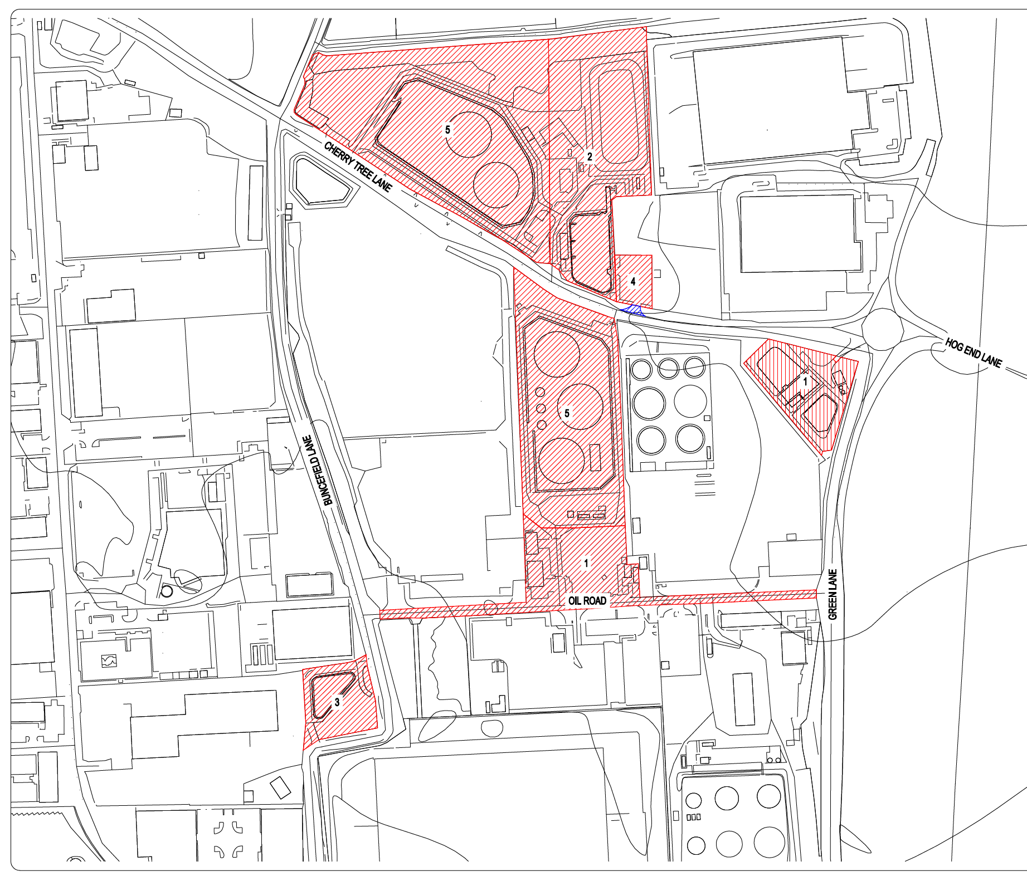

**SCHEDULE 5**

Plan of Kingsbury (Site 2) (**"Site 2 Plan"**)

